- initialize_filetype_magics(self, filetype_magics_file):
- From signature-base/misc/file-type-signatures,
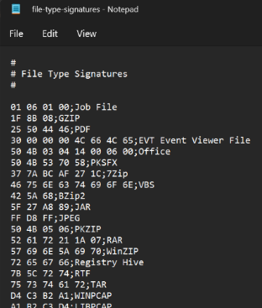
- It consolidates a dictionary of file type signatures for identification of submitted files, e.g. {'01060100': 'Job File', '1F8B08': 'GZIP', '25504446': 'PDF', '300000004C664C65': 'EVT', '504B030414000600': 'Office', '504B537058': 'PKSFX', '377ABCAF271C': '7Zip', '46756E6374696F6E': 'VBS', '425A68': 'BZip2', '5F27A889': 'JAR', 'FFD8FF': 'JPEG', '504B0506': 'PKZIP', …
- Hence, redefining a PDF as an EXE and submitting it will return below results:
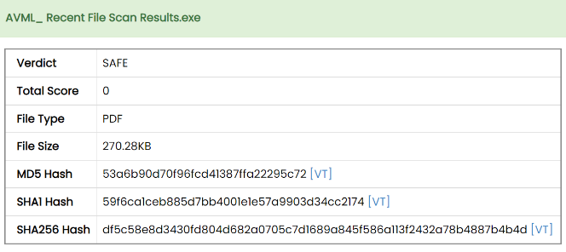

- initialize_hash_iocs(self, ioc_directory, false_positive=False):
- From signature-base/iocs (e.g. hash-iocs),
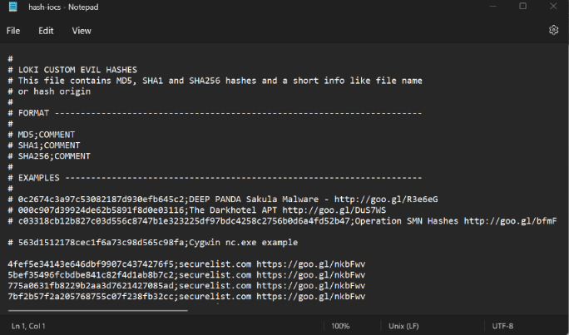
- It converts all the hashes (MD5, SHA1, SHA256) into integer form and consolidates them into a list of converted hashes (hence scanning process will hash submitted file, convert it into integers for comparison: 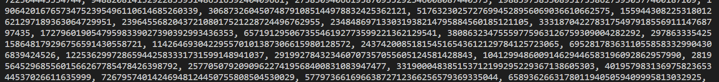
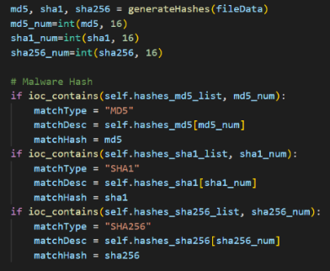
- initialize_yara_rules(self)
- From signature-base/yara, the function iterates through all the .yar files and compiles a list of all YARA rules (<yara.Rules object at 0x0000015C57B6F570>)
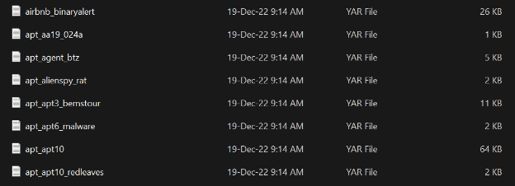
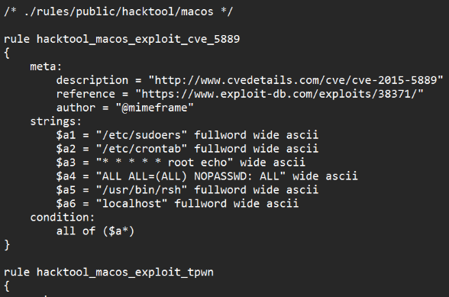

- scan_data(self, fileData, fileType="-", fileName=b"-", filePath=b"-", extension=b"-", md5="-"):
- Matches the compiled YARA rules with the file data.
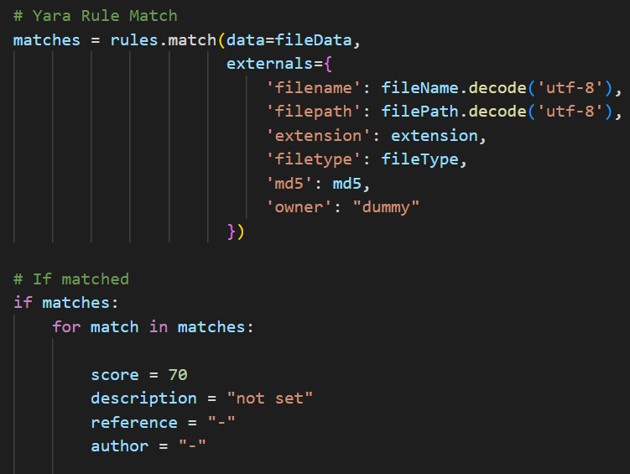
- Every match increases the score by 70.

- script_stats_analysis(self, data)
- Detect obfuscated code in scripts like PHP, JavaScript or PowerShell.
- If anomalies found and final anomaly score exceeds 40, the anomaly score is returned. Otherwise final score is 0.
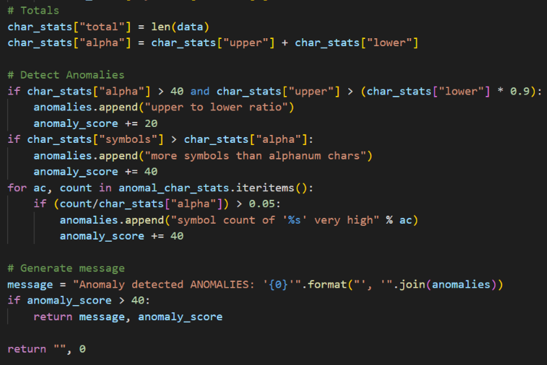
- The original script had some bugs, so I had to fix it:
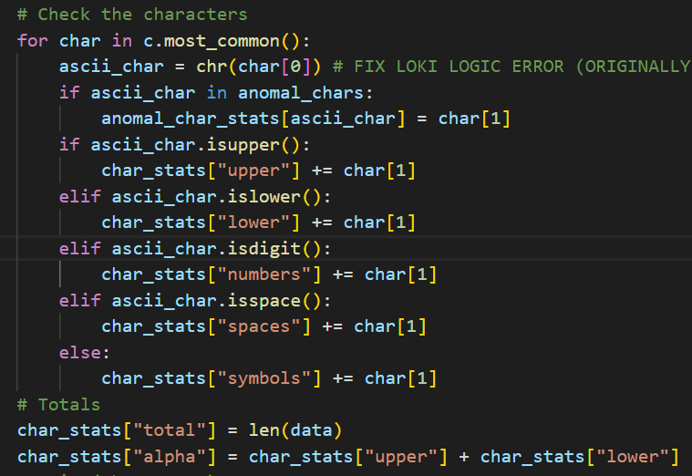
- Some of the output in the process (after adding print statements):
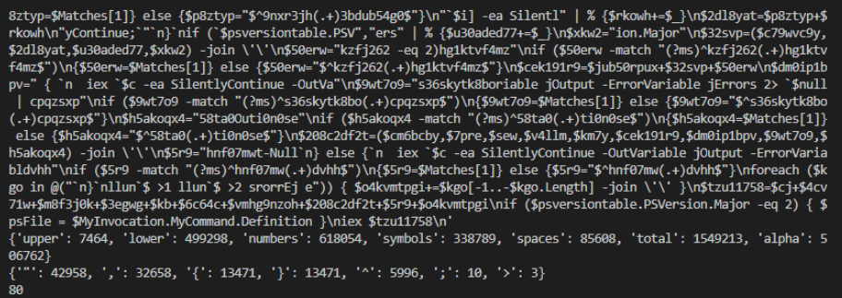
File Data | Character Stats | Anomaly Character Stats | Anomaly Score

- scan_file(self, path)
- Main function that invokes all other scanning modules
- File name check using regular expressions
- Levenshtein check (for similarity in filenames)
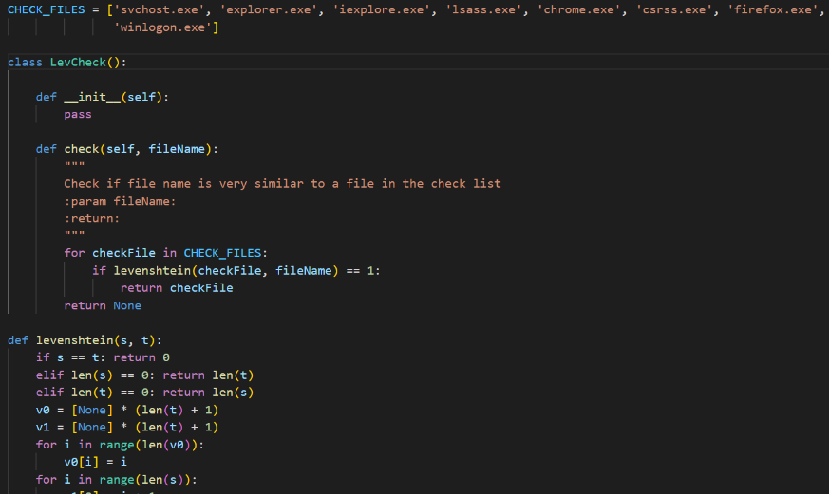
- File type check based on initialize_filetype_magics, if file type signature is not found, then type is UNKNOWN.
- Hash comparison; every match score += 100
- Script analysis; anomaly score > 40 score += anomaly score
- YARA rule match; every match score += 70
- Final scoring system: >= 100 : Alert, >= 60 : Warning, >= 40 : Notice, < 40 : Safe

